VySkan
Product Name | 4G LTE Hardwired Vehicle Tracker
Product Model | VM90-Mini
Versatile. Controllable. Secure.
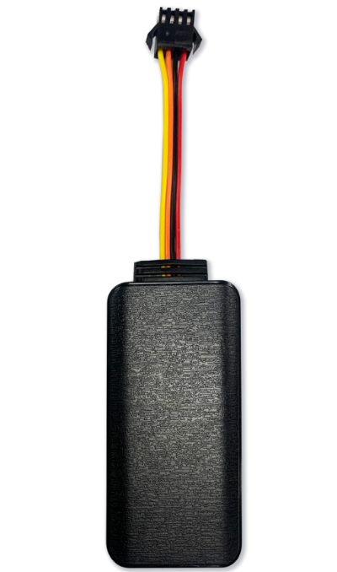
Engineered for versatile fleet management and asset protection, the VM90-Mini is a robust 4G LTE hardwired tracker designed to adapt to almost any vehicle. Featuring an ultra-wide operating voltage and remote immobilization capabilities, it delivers absolute control and real-time visibility over your diverse fleet operations.
- Core Value
- Ultra-Wide Voltage Compatibility
Operating flawlessly between 9V and 90V DC, the VM90-Mini is a universal solution. It seamlessly integrates into passenger cars, heavy-duty commercial trucks, motorcycles, and e-bikes without the need for external voltage converters.
- Remote Immobilization & Control
Take immediate action against unauthorized use or theft. Through a dedicated relay connection, fleet managers can execute remote fuel or power cut-off commands directly from the platform or via SMS.
- Uninterrupted Trajectory & Security
Network blind spots? The device automatically stores location data during cellular drops and uploads it upon reconnection. The built-in 50mAh backup battery ensures you receive critical wire-cut and low-battery alerts even if the main power is sabotaged.

- Proactive Asset Defense
Equipped with a comprehensive multi-alert system, including vibration detection, geo-fencing (boundary breaches), and over-speed alarms (configurable from 0-255km/h) to enforce driver safety and compliance.
- Target Applications
- Logistics & Delivery Fleets (Cross-border tracking, versatile vehicle compatibility)
- Motorcycle & E-bike Management (High voltage support, anti-theft tracking)
- Car Rental & Auto Finance (Remote engine immobilization, risk mitigation)

Technical Specifications
3.1 Cellular & GNSS
Category | Specification | Description
Network Bands | 4G LTE & 2G GSM | FDD-LTE: B1/B3/B5/B8;  TDD-LTE: B34/B38/B39/B40/B41;  GSM:850/900/1800/1900MHz. (Global/Regional bands optional ).
Hardware Platform | UIS8910DM | High-performance  communication module.
GNSS Chip | AT6558R (GPS + BDS) | Multi-constellation support for pinpoint accuracy.
Antenna | Built-in Ceramic Antenna | 25mm25mm2mm high-gain antenna for strong signal lock.
Sensitivity | Tracking:-162dBm | Reliable positioning even in dense environments.
3.2 Power & Electrical
Category | Specification | Description
Operating Voltage | DC 9V - 90V | Ultra-wide range compatible with everything from e-bikes to heavy trucks.
Working Current | 30mA- 60mA @ 12V | Standard active tracking mode.
Sleep Current | 5mA - 15mA @ 12V | Power-saving mode.
Backup Battery | 50 mAh | Ensures final alerts during unauthorized power disconnection.

3.3 Interfaces & Expandability
Category | Specification | Description
Wiring Harness | 4-Wire Interface | Red (Power), Black (Ground), Orange (ACC Detection), Yellow (Relay Control).
Smart Alarms | Wire-cut, Vibration, Over-speed | Comprehensive built-in alerts for maximum security.
Immobilization | Relay Supported | Enables remote fuel and power cut-off functionality.
Optional Add-ons | SOS Button, Microphone, Wi-Fi | Expandable features for voice monitoring and emergency alerts.

3.4 Physical & Environmental
Category | Specification | Description
Weight | 140g | Sturdy and compact.
Housing Material | ABS Plastic | Industrial-grade durability.
Operating Temp. | -30℃ to 75℃ | Resilient operation in extreme climates.
Maintenance | OTA Supported | Supports Over-The-Air firmware updates for easy maintenance.

- Built for Rapid Integration
- Standard Protocols: Natively supports TCP transmission and offers a choice between standard JTT808 or GT06 protocols.
- OTA Ready: Supports dual-mode remote upgrades (Platform + SMS) to minimize maintenance costs.
- A personalized service prepared for you
- 1× VM90-Mini Sample Device (Pre-configured)
- Full API & Protocol Documentation
- 1-on-1 Technical Support from our Field Engineers
- Contact us
Website：https://vyskan.com/
Email: marketing@vyskan.com

